PHASE **2**  
JOHN HOANG | OLIVER JANG | HENRY JIANG | HARMAN MINHAS

overview  
  
Phase 2 of SuperPoints will be based on introducing functionality that was not originally designated as core and was deemed extraneous to the prototype we agreed to develop with our client. Phase 2 will also include the continual refinement of the core functionality that we have developed over the course of 3900. Aesthetically our application will undergo an overhaul over the 5 weeks of 4900. As it stands most user interface elements were added as a framework for future enhancements which will now occur in this phase. Best coding practices will also be implemented as well. A simplistic user guide will also be provided to our client, the application is intuitive by nature, thus a minimalistic approach is appropriate.

agile development

The 5 weeks will be broken down into weekly sprints. Each sprint will focus on a different aspect of the application as described above. The final week will be a safety net for any shortcomings produced in the previous weeks. Each week will include a small design period, 1-2 days, implementation over the next 3 days, and 1 – 2 test days. One day, Friday will be reserved for a progress report by the team, and for catching up/helping others with their respective parts. This schedule will vary slightly depending on the week, for instance the aesthetic portion will be comprised of a higher period of design and less on implementation and testing. The schedule will be strictly adhered with modifications in their weekly breakdown depending on what is seen fit based on the stage, but the above provides a flexible schedule to keep in mind as we progress. Meetings will be interweaved as seen fit, with an exception of the first week, in which a full demo of the prototype will be performed for our client.

**document version**

|  |  |  |  |
| --- | --- | --- | --- |
| **version** | **description** | **date** | **author(s)** |
| **1** | created | 04/05/2019 | john |

## 

**contact**

|  |  |  |
| --- | --- | --- |
| name | email | phone |
| john hoang | johnquochoang@gmail.com | (778) 870-5011 |
| oliver jang | [jangoliver@gmail.com](mailto:jangoliver@gmail.com) | (778) 806-5406 |
| harman minhas | harman_minhas@outlook.com | (778) 683-2044 |
| henry jiang | [henryjiang@live.ca](mailto:henryjiang@live.ca) | (778) 829-2908 |
| reese williams | redsaw.digital@gmail.com | (778) 302-6387 |

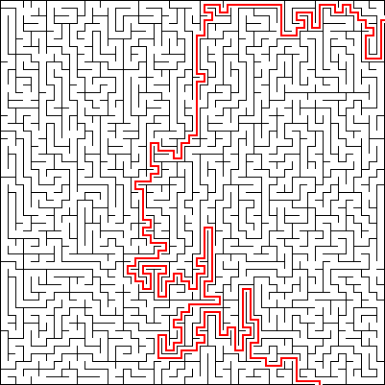

the plan

**WEEK 1:** aesthetics

The first week will consist of UI enhancement. The goal is to incorporate modern design and generate appeal. A consistent style will be implemented across all activities of the application. Current design trends of successful applications employ high contrast coloring, block segmentation of the interface, a bottom up application bar, and low levels of interactions needed for the consumer to get what they want. These concepts will be the core of the design.

Designs will be run against feedback by our client, and of course our own opinions. This will consist of an in-person meeting, as well as web communication as design choices are made.  
Styling will be made universal between our views to make design changes easier for us to implement allowing more time for feedback.

Here are some design patterns we hope to emulate; we do not have the resources for images, however. No schedule is provided here as it will be unpredictable design, implementation, feedback loops.

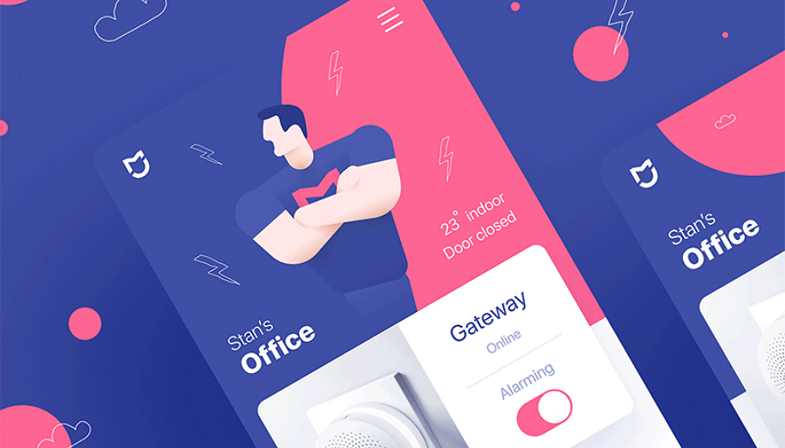

Figure 1. High contrast color design we hope to emulate

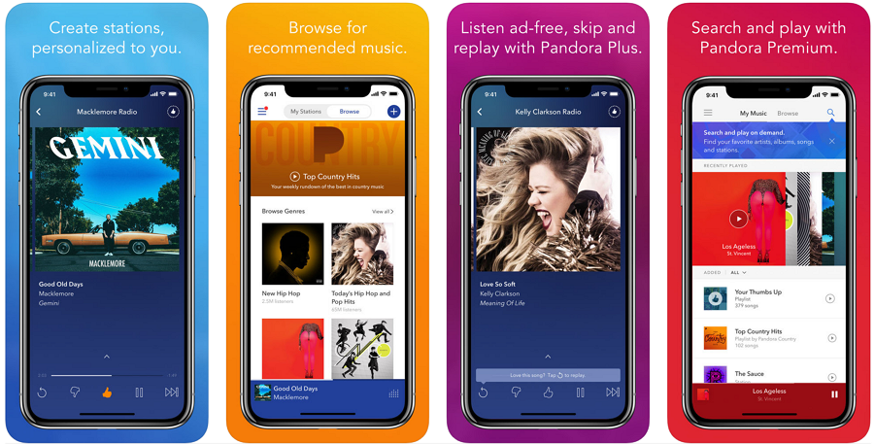

Figure 2 Bottom up application bar, color blocking segmentation we hope to emulate

**WEEK 2-3:** bells and whistles

These two weeks will be dedicated to the “bells and whistles” that were initially discussed in the beginning of 3900 with our client. The goal is to add to the foundation in place and cement our applications utility to both businesses and shoppers.

businesses week 2

These features primarily provide business value and a selling point for our client to propel the product. As it currently stands, the product delivers the business an idea of how busy their store is, and the average duration of a visit. This of course can be expanded upon; graphical representations will not be provided but more analytics can be aggregated to provide a more appealing vantage point for businesses.

|  |  |
| --- | --- |
| Task | Days |
| Design | 1-2 |
| Views per promotion | 1 |
| List of best customers | 1-2 |
| Testing | 1 |

admins/users week 3

Administrators of the application will be needed if further development past the prototype stage is to occur. This will be provided in the form of a login/or set of logins with administrator capabilities. Administrators will be able to add businesses/edit/ and delete businesses. The same set of features will be available for users, as well as editing points. These will be provided at the application’s UI level. Any further beyond the surface level changes will be done through the database by using phpMyAdmin, a basic guide for common administrator options beyond the above will be provided.

Users will be allowed to “prefer” businesses, this means promotions for them will be prioritized for appearance in their promotions. This will be through simply clicking on the corresponding business marker on the map, changing it to a star. A list view will be provided allowing a user to view their preferred business and delete them if desired.

For this portion the team will split, two developers will work the administrator functionality and minimalistic phpMyAdmin guide (task set A). One developer will be assigned to develop the pages for the administrator to use (task set B). The final developer will work on the user aspects (task set C).

|  |  |
| --- | --- |
| Task Set **A** | Days |
| Design | 1 |
| A/E/D businesses | 1-2 |
| A/E/D users | 1-2 |
| phpMyAdmin guide | 1 |
| Testing | 1 |

|  |  |
| --- | --- |
| Task Set **B** | Days |
| Design | 2 |
| A/E/D businesses activity | 1 |
| A/E/D users activity | 1 |
| Styling | 1 |
| Testing | 1 |

|  |  |
| --- | --- |
| Task Set **C** | Days |
| Design | 1 |
| Prefer businesses | 1 |
| List view of preferred | 1-2 |
| Deletion of preferred | 1 |
| Testing | 1 |

**WEEK 4:** polish

This week is fully dedicated to polishing. The goal is simple here, iron out any kinks and deliver an application worthy of deployment. This will involve a lot of testing and minor modifications. Production code is also key here. Development over this strenuous period has caused good coding practices to be abandoned and a “get it done” mentality as opposed to a “do it right” mindset, Comments will be provided, variable refactoring and general restricting will be performed in this week. Functions will be broken down to simpler functions. We believe this will provide large value to any future developers that work with the code, saving our client expenses and developers headaches. Simultaneously, rigorous edge case testing will be done here to ensure a smooth user experience. Bugs will be reported and the most knowledgeable member pertinent to the category of bug will be assigned to it.

|  |  |
| --- | --- |
| Task | Days |
| Break the code | 1-2 |
| Fix the code | 2 |
| Comment/refactor/hierarchy redesign the code | 2 |
| Test our fixes | 1 |

productionCodeGuideline

1. Variables common to a functionality will be grouped and a single comment line will describe the functionality they are related to.

//Google Map API client related variables  
private GoogleMap mMap;  
private GoogleApiClient mGoogleApiClient;  
private LocationRequest mLocationRequest;

1. Functions will have a comment saying their purpose. They will also have a singular purpose, and thus should be minimal.

//Shows a notification in the users notification pool  
static public void showNotification(String title, String text, PendingIntent pendingIntent, Context callingContext)

1. There will be no “god-classes”.
2. Variable and function names will be camelCase and if clarity is not possible in the name, it will be provided in additional comments.

**WEEK 5:** homestretch

This week will address any shortcomings, mishaps, and misunderstandings that happened over the previous weeks. The user guide will be implemented and given to our client during this period as well. There will be a final meeting with the client to discuss the future of our relationship as well as to reflect on the journey and display the application in its final form with us at its head.

|  |  |
| --- | --- |
| Task | Days |
| Address outstanding issues | 5 |
| User guide | 1 |
| Final meeting | 1 |